1. Open the browser of your choice, Launch the URL <https://demoblaze.com/index.html#>, Choose Laptops

Select the first Laptop from the result, Proceed with Add to Cart, Attach the output screenshot.

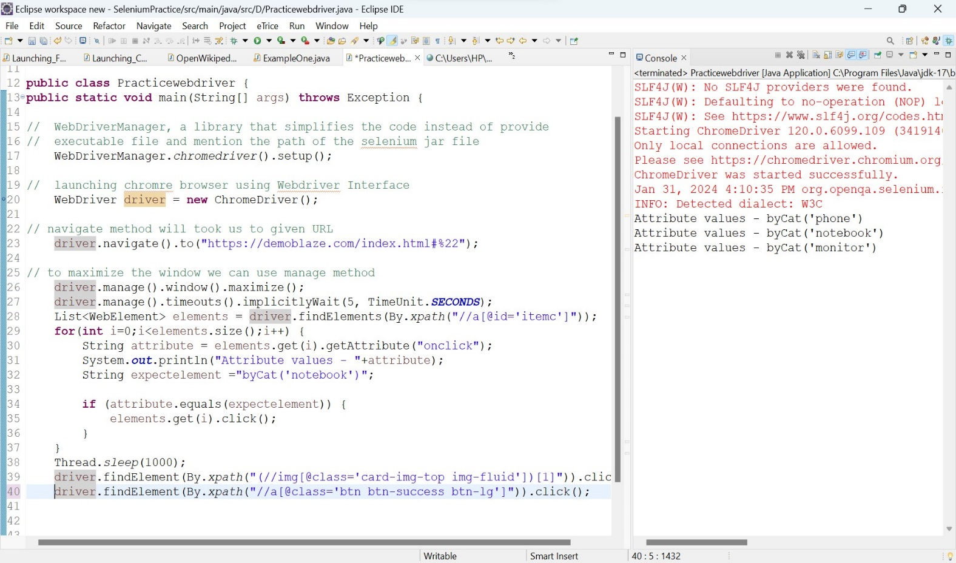

Here we are going to evaluate <https://demoblaze.com/index.html#>, page particularly to check can we add to cart a laptop inside the webpage.

* First we have to declare WebDriver manager, it is a library that simplifies code instead of provide executable file and mention the path of the selenium jar file.
* Then we create instance of Webdriver interface to launching the chromeBrowser
* To load the URL there is a method called get(); so we can use this method to laod the URL
* Maximize the Browser we will be make change entire browser so we can use driver.manage()

Window().maximize();

* Here we throw the implicitlywait for 5 seconds entire operation
* Then take the list of web elements using findElements();
* and select the one what we want to choose using for loop;
* here first we take the all Attribute names for elements and click what we have to buy
* then click the add to cart product box
* verify the alert message is shown or not
* take the screen shot manually to create the report

Report

